CHAPTER 1
INTRODUCTION

Skilling the rural population is a vital step toward empowering individuals, reducing unemployment, and fostering self-reliant communities. By offering vocational and entrepreneurial training tailored to local needs—ranging from traditional trades to modern skills like digital literacy—this initiative creates sustainable livelihood opportunities and curbs rural-to-urban migration. It not only boosts economic resilience but also uplifts marginalized groups, especially women, thereby strengthening the social and economic fabric of rural India. Investing in rural skill development is a move toward a more inclusive, equitable, and prosperous nation.
Water is one of the most vital natural resources for human survival, yet it is increasingly under threat due to population growth, urbanization, climate change, and unsustainable usage. Rainwater harvesting (RWH) offers a practical, cost-effective, and eco-friendly solution to address water scarcity. Despite its many benefits, awareness and adoption of rainwater harvesting practices remain low, particularly among the general public in both urban and rural areas.
Creating awareness about rainwater harvesting is essential to promote its widespread implementation and to foster a culture of water conservation. In urban areas, where concrete structures dominate and groundwater levels are depleting, rooftop rainwater harvesting systems can help meet daily water needs and reduce the burden on municipal supplies. In rural areas, simple and traditional methods of rainwater collection can play a crucial role in supporting agriculture, livestock, and household needs, especially during dry seasons.
This initiative aims to inform and educate people about the significance of harvesting rainwater, the techniques available, and the long-term environmental and economic benefits. Awareness programs, workshops, campaigns, and school-based activities can inspire communities to take proactive steps in managing water wisely. By bridging the knowledge gap and motivating action, this effort supports sustainable development and ensures that future generations have access to this precious resource.

CHAPTER 2
TO SKILL RURAL POPULATION
2.1 OVERVIEW
India’s rural population forms the backbone of the nation, yet many in these areas face limited access to quality education, vocational training, and employment opportunities. As the country progresses toward a knowledge and service-driven economy, bridging the skill gap between urban and rural communities has become a critical need. The "Skilling the Rural Population" initiative is designed to empower rural individuals by equipping them with practical, job-oriented skills that enhance their employability and promote self-reliance.
This activity involves a structured approach to identifying local skill gaps and tailoring training programs that align with both community potential and market demand. These programs cover a wide range of traditional and modern skills, including agriculture, carpentry, plumbing, tailoring, food processing, digital literacy, mobile repair, solar panel maintenance, and more. The goal is not only to create job opportunities but also to encourage entrepreneurship and small-scale enterprises that can thrive within rural settings.
A special focus is placed on including youth, women, and marginalized groups in the training efforts to ensure inclusive growth and social equity. Skilling initiatives also serve to reduce the pressure on urban areas by curbing rural-to-urban migration, as individuals are able to find viable livelihoods within their own communities.
The impact of this activity extends beyond economic development. It fosters a sense of dignity, confidence, and empowerment among rural citizens, enabling them to contribute more meaningfully to society. In the long term, skilling the rural population helps build resilient communities, supports sustainable development, and narrows the rural-urban divide, laying the foundation for a balanced and prosperous nation.
2.2 USE OF TECHNOLOGY
Use of Technology in Skilling the Rural Population – on Online Transaction’s
Technology has become a powerful enabler in rural skill development, just as digital payment platforms like PhonePe have simplified financial transactions for rural users. In the same way, smartphones and mobile applications are now being used to deliver skill training, improve digital literacy, and connect rural individuals to job and entrepreneurship opportunities.
- Digital Literacy Training: Rural people are taught how to use smartphones, apps like PhonePe, and digital services-essential skills for both employment and running small businesses.
- Online Skill Courses via Mobile Apps: Apps such as SWAYAM, eSkill India, and YouTube offer vocational and technical training in regional languages, accessible on the same phones used for PhonePe.
- Entrepreneurship through Digital Payments: Once skilled, rural youth and women can start small businesses and receive payments through PhonePe or UPI, encouraging self-employment and financial independence.
- E-Certification and Job Matching Platforms: Technology helps candidates receive digital certificates and register on job platforms like NSDC, which work similarly to mobile-based interfaces like PhonePe.
- Awareness through Social Media and WhatsApp: Like PhonePe promotes its services online, awareness campaigns for skill development programs are also run using social media, WhatsApp, and local-language audio-visual content.
2.3 SUSTAINABLE DEVELOPMENT BEST PRACTICES
Digital Literacy Campaigns
- Conduct weekly digital boot camps in local schools or community halls.
- Partner with Common Service Centres (CSCs) to provide access to digital services.
- Provide certification for trainees to encourage participation and credibility.
Use of Visual and Interactive Learning
- Design videos in regional languages showing step-by-step transactions (UPI, ATM, etc.).
- Simulate real-life situations such as paying bills, checking balances, or sending money.
- Use story-based roleplays to make learning relatable and engaging.
Promoting Cybersecurity Awareness
- Conduct mock drills on phishing scams and fraud calls.
- Distribute a cybersecurity checklist (Do’s & Don’ts) in print and digital form.
- Promote government apps like BHIM and Digilocker for secure transactions.
Inclusion and Gender Equity
- Create women-centric groups to build trust and confidence in using mobile banking.
- Special outreach to self-help groups (SHGs), Anganwadi workers, and farmers.
- Provide basic mobile training for elderly and illiterate participants using symbols and voice guidance.
Sustainable Outreach Models
- Launch a “Train-the-Trainer” model—empower one person from each village cluster.
- Set up digital helpdesks at Panchayat Bhavans or local shops.
- Leverage WhatsApp and Telegram groups to share daily updates and tips.

CREATING AN AWARENESS REGARDING RAIN WATER HARVESTING IN URBAN AND RURAL AREA
2.1 OVERVIEW
Water scarcity is a growing concern in many parts of India, affecting both urban and rural populations. Rapid urbanization, deforestation, and overuse of groundwater have led to declining water levels and seasonal shortages. Rainwater harvesting (RWH) is a simple yet effective technique to conserve water by collecting and storing rainwater for reuse. To address this critical issue, creating awareness about rainwater harvesting has become essential in promoting sustainable water management practices across urban and rural areas.
The awareness initiative aims to educate communities about the importance, benefits, and methods of rainwater harvesting. In urban areas, it focuses on rooftop rainwater collection systems, integrating RWH with buildings and promoting water reuse for household and gardening purposes. In rural regions, the emphasis is on traditional and low-cost harvesting techniques like percolation pits, farm ponds, and check dams to recharge groundwater and support agricultural needs.
Various innovative methods are used to spread awareness, including community meetings, school workshops, street plays, short videos, wall paintings, and digital campaigns. Demonstration models are installed in public spaces to show how RWH systems work in real life. Local government bodies, NGOs, and environmental groups collaborate to implement these programs and encourage community participation.
By raising awareness and promoting action, the initiative contributes to water conservation, reduces dependence on external water sources, and strengthens local water security. It also aligns with sustainable development goals, especially SDG 6: Clean Water and Sanitation. Creating awareness about rainwater harvesting is a vital step toward ensuring a water-secure future for both urban and rural communities.
2.2 USE OF TECHNOLOGY
- Interactive Mobile Campaigns: Awareness about rainwater harvesting is spread through mobile-based campaigns using WhatsApp, SMS, and voice messages in regional languages. These messages include simple, actionable tips and motivational success stories that even non-literate users can understand. Additionally, short video clips and animated infographics are shared on platforms like YouTube and Facebook to engage both rural and urban audiences in an easy and relatable format.
- IoT-Based Rainwater Monitoring Systems: In urban and institutional buildings, Internet of Things (IoT) devices are used to monitor water collection, storage levels, and usage patterns. These smart systems help in efficient management of harvested rainwater, reduce wastage, and provide real-time data that can be accessed via mobile apps. They also serve as live demonstration models that can be used to raise awareness in schools and residential societies.
- Augmented Reality (AR) & 3D Simulations: Augmented Reality (AR) and 3D animation technologies are used to create interactive demonstrations of rainwater harvesting systems. These tools visually explain how rainwater is collected from rooftops, filtered, and stored for reuse. AR experiences can be accessed through mobile phones and used in community workshops, educational institutions, and awareness camps to provide an immersive learning experience.
- Community Radio & Interactive Voice Response (IVR) Systems: In areas with limited internet access, community radio stations and IVR systems play a key role. Pre-recorded messages, jingles, and expert interviews are broadcasted through local FM channels to educate listeners on the benefits and techniques of rainwater harvesting.
- Online Rainwater Harvesting Calculators & Planning Tools: Websites and mobile apps now offer rainwater harvesting calculators where users can input details like roof size and average rainfall to estimate potential water collection. These tools assist individuals and communities in planning customized harvesting systems and calculating return on investment (ROI), thus encouraging more households and institutions to adopt sustainable water practices.
2.3. SUSTAINABLE DEVELOPMENT BEST PRACTICES
- Community Participation and Ownership
- Involve community members in the planning, digging, and maintenance of ponds or recharge pits.
- Use participatory rural appraisal (PRA) methods to identify the best locations.
- Eco-Friendly Pond Construction
- Use locally available, natural, and sustainable materials for digging and lining ponds.
- Avoid cement linings to promote groundwater recharge.
- Education and Demonstration Models
- Set up a model rainwater harvesting pond in a school, community center, or panchayat office as a live example.
- Use posters and 3D models to explain the water cycle and benefits.
- Urban-Rural Synergy
- Promote rooftop rainwater harvesting in urban areas and link awareness drives with smart city goals.
- Use social media to connect urban students with rural initiatives.
- Monitoring and Long-Term Impact
- Use simple measurement tools (e.g., water level markers) to show how much water is harvested.
- Involve local schools or NGOs in maintaining records and ensuring sustainability.

CHAPTER 3
3.1 INNOVATIVE APPROACHES
- INNOVATIVE APPROACHES OF TO SKILL RURAL POPULATION
- Gamified Learning Modules
  - Developed mobile-friendly quiz apps or games in local languages to teach online transaction steps and safety tips in an interactive manner.
- Voice-Assisted Training using AI Chatbots
  - Used WhatsApp-based or IVR-enabled AI chatbots for step-by-step guidance on how to use UPI and digital wallets in native languages (e.g., Telugu, Hindi).
- Digital Literacy on Wheels
  - Launched a mobile van with laptops and internet to travel across villages, offering on-the-spot digital transaction demos.
- QR Code Challenge
  - Conducted contests encouraging villagers to complete simple tasks using QR-based transactions in local kirana shops.
- "Each One Teach One" Digital Model
  - Trained school students and digitally literate youth to mentor one elderly or untrained person in their community on using transaction apps.
- Use of AR (Augmented Reality) Cards
  - Distributed physical cards with AR codes linked to simple video tutorials when scanned using a phone camera.
- Digital Transaction Simulation Booths
  - Set up booths with a mock interface and dummy currency to simulate UPI and card payments in a risk-free, practice-first environment.

- INNOVATIVE APPROACHES OF CREATING AN AWARENESS REGARDING RAIN WATER HARVESTING IN URBAN AND RURAL AREA.
1. Pond Adoption Program ("My Pond, My Pride")
- Local schools or families adopted specific ponds to take responsibility for maintenance, cleanliness, and awareness drives.
2. Rain Gauge DIY Kits
- Distributed low-cost, do-it-yourself rain gauge kits (plastic bottle-based) to schools and homes for real-time rainfall tracking.
3. Gamification of Water Conservation
- Launched a mobile/web leaderboard where schools and panchayats earned points for adopting rainwater harvesting, tree planting, and water-saving practices.
4. Drone-based Water Mapping
- Used drone images and open-source GIS tools to identify high runoff areas and potential pond locations in both urban and rural areas.
5. Pond Beautification with Local Art
- Engaged local youth and artists to paint environmental murals around pond boundaries to make them attractive and educational.
6. Rainwater Harvesting Hackathon
- Organized a student hackathon to create low-cost, smart sensor systems to monitor water levels in ponds and trigger alerts for overflow or maintenance needs.
7. Storytelling and Folk Theater ("Jal Kahani")
- Used street plays, puppet shows, and folk songs to spread awareness about rainwater harvesting in an entertaining yet impactful way.

  - RESEARCH DONE
- Consumer Intention to Adopt E-Wallets in Rural India: An Investigation by Extending the Technology Acceptance Model, Mohammed Rashid, Mushahid Ali Shamsi, Imran Anwar, Imran Saleem, Ali Thabit Yahya
This study examines the factors influencing the acceptance of e-wallets among Indian rural consumers. By extending the Technology Acceptance Model (TAM) to include Digital Financial Literacy (DFL) and Perceived Financial Risk (PFR), the research analyzes their effects on consumers' attitudes and intentions to adopt e-wallet services. An online survey with 720 respondents from Uttar Pradesh was conducted, and Structural Equation Modelling was used for analysis. Findings indicate that DFL positively influences Perceived Usefulness and Perceived Ease of Use, while PFR negatively impacts them. The study offers insights for enhancing digital financial inclusion in rural areas.
- Adoption of UPI (Unified Payments Interface) by Rural People: An Empirical Investigation
This empirical study investigates the adoption of UPI among rural populations. It identifies key factors such as awareness, trust, and perceived ease of use that influence the adoption rate. The research highlights the need for targeted educational programs to enhance digital payment adoption in rural areas.
- Sustainable Water Resources Through Harvesting Rainwater and the Effectiveness of a Low-Cost Water Treatment, Samia Richards, Lakshminarayana Rao, Stephanie Connelly, Anjali V Raj, et al.
This study evaluates a rooftop rainwater harvesting system installed in a rural Indian school as part of a decentralized wastewater treatment system. It assesses the system's effectiveness in reducing groundwater dependency and examines the quality of stored rainwater over time. The research also investigates a low-cost chlorination treatment to ensure the safety of harvested water. Findings suggest that regular chlorination maintains microbial quality within acceptable standards, making the system a viable solution for sustainable water management in rural settings.

- Impact of Rainwater Harvesting Structures on Water Table Behavior and Groundwater Recharge in Parasai-Sindh Watershed of Central India, Reena Kumari, Ramesh Singh, R.M. Singh, R.K. Tewari, S.K. Dhyani, Inder Dev, Babloo Sharma, A.K. Singh
The study analyzes the impact of rainwater harvesting structures on groundwater recharge in the Parasai-Sindh watershed. By constructing 10 cost-effective structures, the research observed a 69% increase in water column during monsoon seasons and a 71.8% rise in net groundwater recharge post-intervention. The findings demonstrate the efficacy of rainwater harvesting in enhancing water availability for irrigation and reducing fallow land in the region
3.3 KNOWLEDGE AND UNDERSTANDING GAINED
- TO SKILL RURAL POPULATION
- Digital Literacy Gap:
  - Learned that many rural residents had access to smartphones but lacked awareness of secure digital transaction practices.
  - Understood that language barriers, fear of fraud, and lack of confidence hinder adoption.
- Effective Communication Strategies:
  - Realized that training in the local language with real-time demonstrations (live apps, simulation) significantly improves understanding.
  - Visual aids, repetition, and community participation proved crucial for knowledge retention.
- Cybersecurity Awareness:
  - Gained insight into common scams such as phishing, fake UPI handles, and OTP frauds.
  - Emphasized the need to educate users on secure digital behavior (e.g., never sharing OTPs).

- Behavioral Shifts:
  - Observed a gradual change in behavior—from cash-dependency to digital comfort—when trust and knowledge are built.
  - Women and youth emerged as early adopters and future trainers in their communities.
- Sustainable Training Models:
  - Learned the effectiveness of peer learning and "train-the-trainer" approaches in rural settings.
  - Discovered the role of SHGs, Anganwadi workers, and local shopkeepers in expanding outreach.
- CREATING AN AWARNESS REGARDING RAIN WATER HARVESTING IN URBAN AND RURAL AREA
1. Water Scarcity and Community Impact:
- Understood the severe depletion of groundwater in both urban and rural areas.
- Realized that lack of awareness and poor planning lead to ineffective water management.
2. Localized Solutions Work Best:
- Learned that small, decentralized rainwater harvesting structures like ponds and rooftop systems are most effective.
- Engagement with community members improves both design and maintenance outcomes.
3. Cost-Effectiveness and Sustainability:
- Gained understanding of how low-cost harvesting methods (like soak pits, check dams, percolation tanks) can lead to long-term water security.
- Realized that construction is not enough—community ownership and monitoring are vital.
4. Educational and Visual Tools:
- Found that models, charts, murals, and demonstrations in schools and public places boosted understanding and curiosity.
- Students and youth became effective ambassadors for rainwater harvesting messages.
5. Interconnectedness of Nature and Livelihoods:
- Recognized the link between rainwater harvesting, agricultural productivity, and ecosystem restoration.
- Understood how water harvesting reduces drought impact, increases irrigation, and supports biodiversity.
3.4 PROFESSIONAL VALUES AND BEST PRACTICES INCORPORATED
Empathy, social responsibility, ethical conduct, and teamwork were actively fostered through direct engagement with rural and urban communities. Working closely with diverse groups encouraged inclusiveness and cultural sensitivity, ensuring interventions were respectful and accessible across different literacy levels and age groups. Digital literacy efforts emphasized responsible usage, data privacy, and online security, reflecting adherence to ethical standards in the digital domain. In the context of environmental awareness, values of sustainability, community welfare, and ecological responsibility were promoted through hands-on involvement in rainwater harvesting initiatives.
Collaboration with grassroots stakeholders—such as school educators, village heads, and women's self-help groups—ensured that efforts were community-driven and culturally contextualized. Time management, project planning, and adaptability were strengthened by addressing on-ground challenges and modifying strategies based on real-time feedback. Efforts were made to document the process systematically and assess the social impact of the initiatives, reinforcing a professional attitude toward evaluation and improvement. Most importantly, the activities nurtured a strong commitment to nation-building through education, empowerment, and environmental conservation, aligning with the values envisioned in the Sustainable Development Goals and the spirit of institutional social responsibility.

3.5 AREAS FOR FURTHER DEVELOPMENT
TO SKILL RURAL POPULATION ON ONLINE TRANSACTION AWARENESS:
- Develop structured, age-specific digital training modules using interactive content in regional languages.
- Establish local “Digital Mitra” volunteers or help centers for continued support post-training.
- Strengthen collaboration with banks, post offices, and government bodies to build trust and ensure secure adoption.
- Introduce periodic refresher sessions to reinforce digital safety practices and platform updates.
- Incorporate audio-visual content and app simulators to make learning more intuitive for low-literacy participants.
FOR RAINWATER HARVESTING AWARENESS AND IMPLEMENTATION:
- Integrate smart technologies like IoT-based water level monitoring for real-time data collection.
- Conduct skill-building workshops for local youth to manage and maintain water harvesting structures.
- Encourage school-based environmental clubs to promote long-term ecological awareness.
- Link community efforts with government schemes for funding, technical expertise, and scalability.
- Document and share local success stories in vernacular languages to inspire replication in other areas.
- Promote collaboration with environmental experts, NGOs, and civic authorities to support large-scale water conservation planning.

3.6 CHALLENGES AND SOLUTIONS
TO SKILL RURAL POPULATION ON ONLINE TRANSACTION AWARENESS:
CHALLENGES | SOLUTIONS
Limited access to smartphones  or poor internet connectivity | Conducted offline, device-sharing sessions and used printed materials for hands-on learning
Fear of fraud and mistrust in  digital payments | Focused on cybersecurity education and live demos to build trust and familiarity
Low literacy levels among  some community members | Used audio-visual aids, regional language instructions, and icon-based app navigation methods
Hesitancy to adopt new  technologies, especially  among the elderly | Provided one-on-one mentoring and peer support using local youth volunteers
Lack of continuity post-training | Proposed the formation of local digital support groups (“Digital Mitras”) for ongoing guidance

RAINWATER HARVESTING AWARENESS AND IMPLEMENTATION
Challenges | Solutions
Lack of awareness about  the importance of rainwater  harvesting | Conducted awareness drives using street plays, posters, and interactive village sessions
Difficulty in identifying  suitable locations for  harvesting structures | Collaborated with local authorities and used manual terrain surveys for site selection
Limited funds and resources  for digging ponds or  building structures | Mobilized community labor and linked the initiative with government schemes like MGNREGA
Maintenance and upkeep  of structures over time | Encouraged community ownership and appointed local maintenance volunteers
Resistance due to traditional  practicesorlackof immediate benefits | Shared real-life success stories and involved local influencers to advocate for participation

3.7 FEEDBACK AND CONTINUOUS IMPROVEMENT
For the digital literacy and online transaction awareness sessions, participant feedback played a crucial role in shaping improvements. Many attendees, especially the elderly, expressed the need for more visual, hands-on tutorials at a slower pace. In response, step-by-step guides and demonstration videos in regional languages were introduced, along with small-group mentoring to offer personalized support. Community members also suggested including practice sessions for better retention, leading to the development of simulation-based modules and the proposal of forming local “Digital Ambassadors” to provide continued assistance. These changes significantly enhanced engagement and understanding, making the learning experience more inclusive and effective.
In the rainwater harvesting awareness and implementation drive, feedback from both rural and urban participants highlighted a desire for greater involvement in maintenance and technical understanding. Villagers requested training on structure upkeep, while urban stakeholders suggested incorporating rooftop harvesting workshops. Based on this input, community training sessions were organized to teach basic maintenance, and educational materials were distributed to schools and resident groups to reinforce environmental awareness. Future improvements include conducting periodic feedback surveys to assess the long-term impact and introducing user-friendly tools such as low-cost water indicators for better structure monitoring. These initiatives ensure that the project evolves continuously based on community needs and sustainability goals.

CHAPTER 4
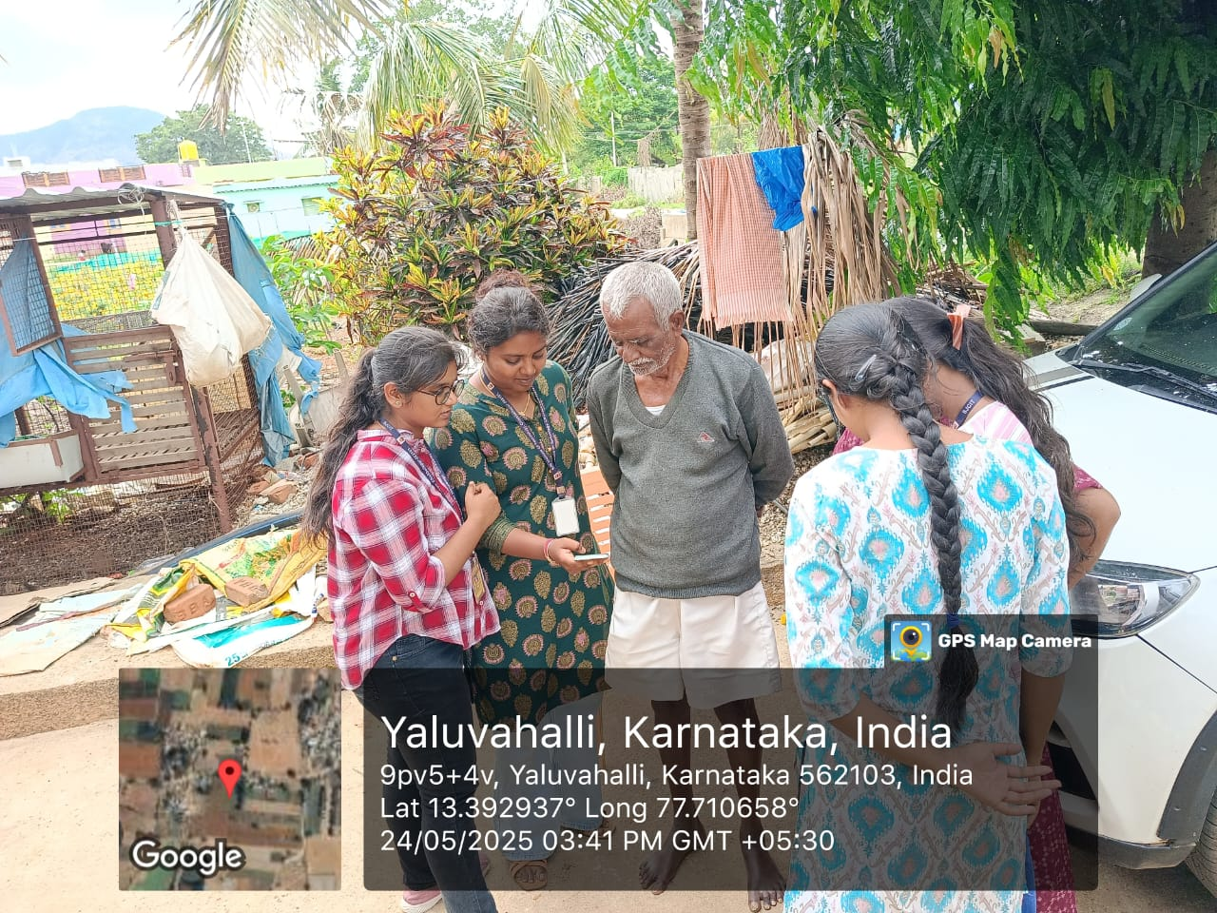
Fig 1: Demonstrating the use of PhonePe app to a local resident.

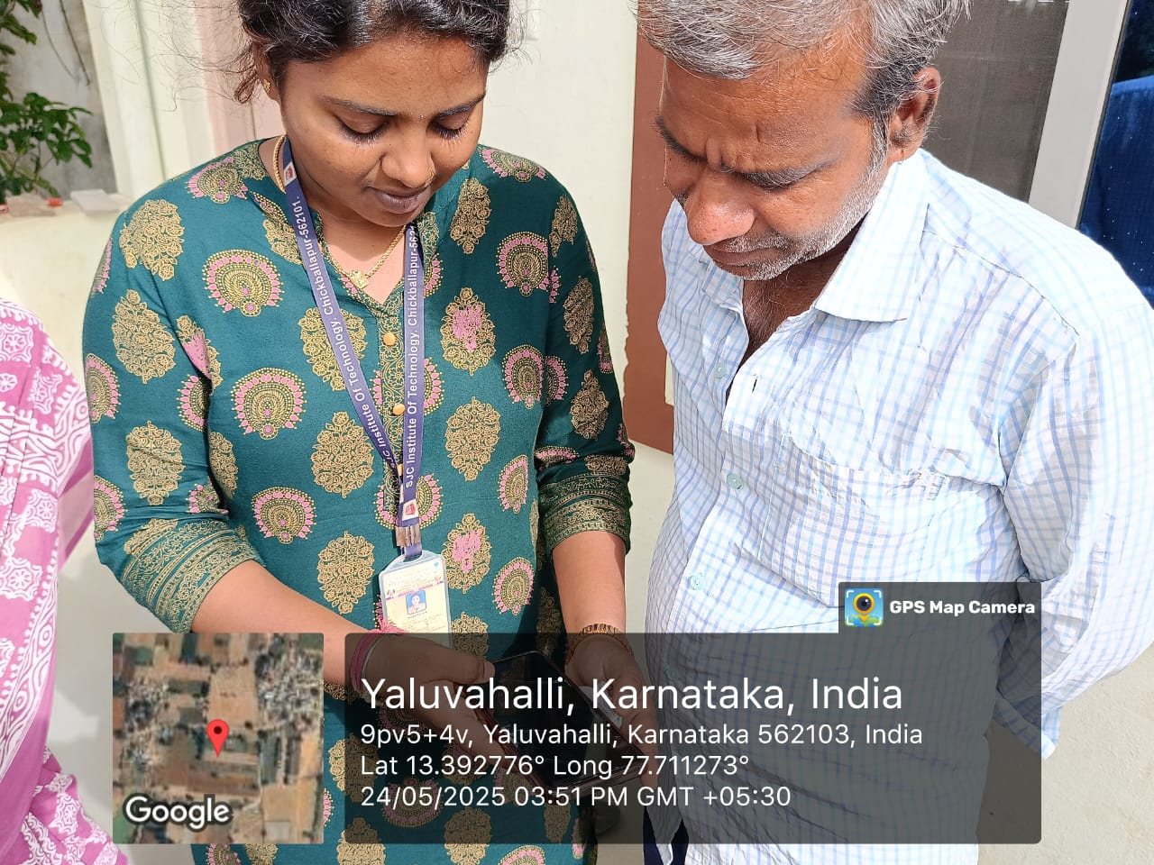
Fig 2: Demonstrating the use of PhonePe app to a local resident.

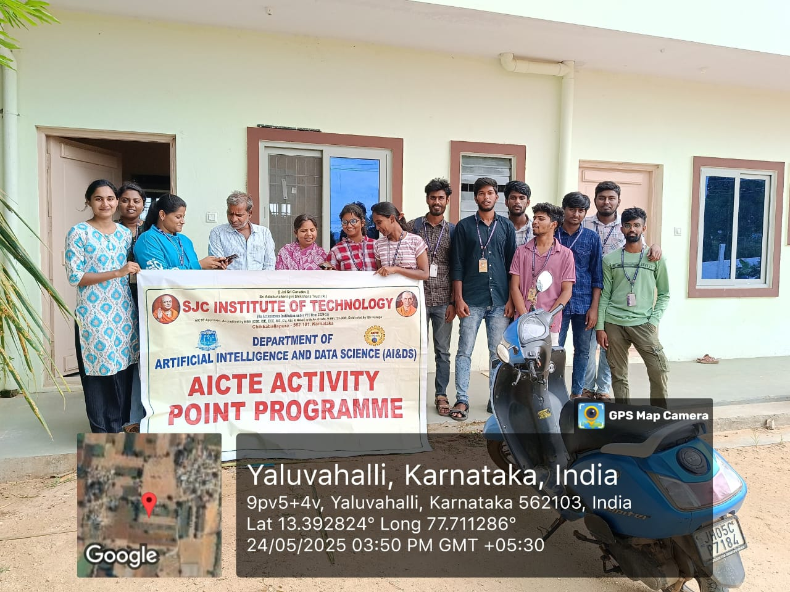
Fig 3: Group Demonstration of PhonePe app usage.
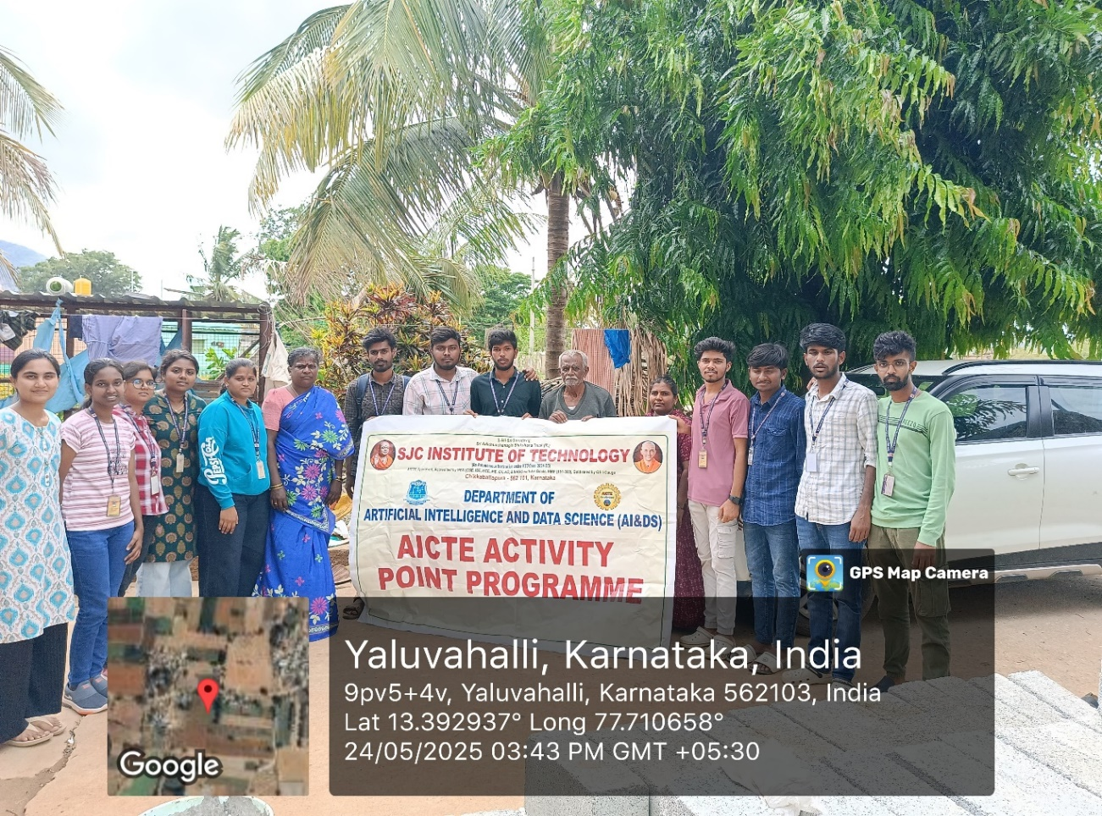
Fig 4: Group Demonstration of PhonePe app usage.

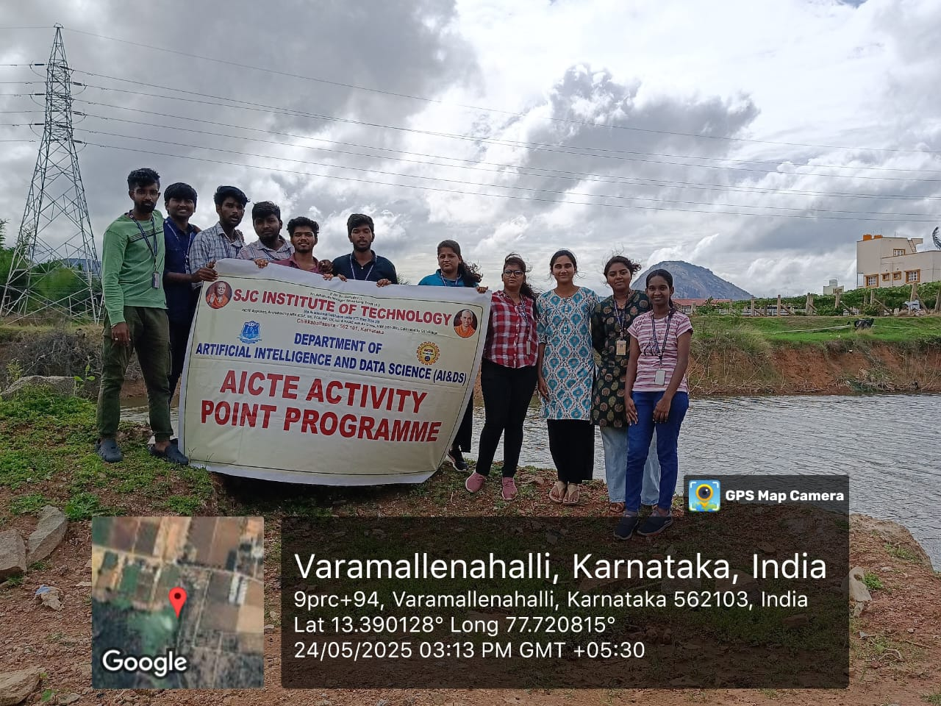
Fig 5:Group Demonstration of Awarness regarding Rain water harvesting
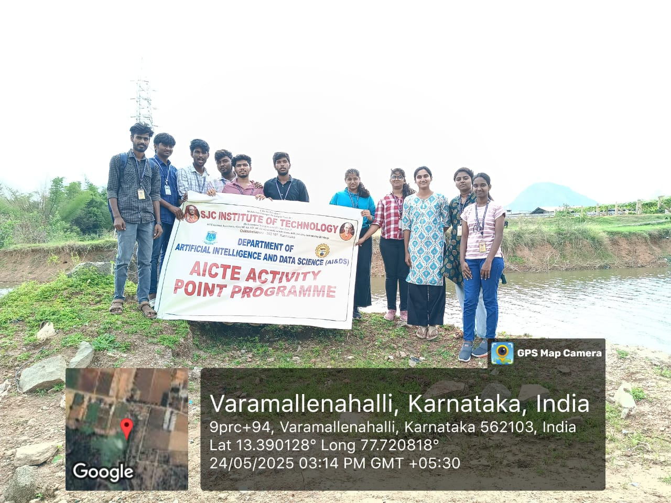
Fig 6:Group Demonstration of Awarness regarding Rain water harvesting
CHAPTER 5
CONCLUSION
The initiatives undertaken to promote digital literacy in rural areas and raise awareness on rainwater harvesting in both rural and urban settings have contributed meaningfully to community empowerment and sustainable development. Through dedicated efforts, rural populations were equipped with essential skills to use online transaction platforms safely and confidently, thereby fostering digital inclusion and financial independence. Simultaneously, the rainwater harvesting awareness drive helped instill environmental responsibility and practical knowledge about water conservation methods, encouraging community participation in preserving local water resources.
Both activities showcased the value of hands-on engagement, community collaboration, and context-specific educational approaches. They also highlighted the importance of continuous feedback, adaptability, and integration of traditional wisdom with modern practices. Most importantly, these efforts reflected a strong commitment to social responsibility, capacity building, and the broader vision of the Sustainable Development Goals. Going forward, such initiatives will serve as a foundation for larger, long-term impact projects that blend technology, sustainability, and community involvement for holistic development.

REFERENCE
- Rashid, M., Shamsi, M. A., Anwar, I., Saleem, I., & Yahya, A. T. (2025). Consumer intention to adopt e-wallets in rural India: An investigation by extending the technology acceptance model. Cogent Business & Management, 12(1). https://doi.org/10.1080/23311975.2024.2428776
- Ministry of Electronics & Information Technology (MeitY). (2022). Digital India Programme Annual Report. Retrieved from https://www.meity.gov.in
- Reserve Bank of India. (2023). Financial Inclusion Index. https://rbi.org.in/Scripts/PublicationVisionDocuments.aspx
- National Bank for Agriculture and Rural Development (NABARD). (2021). All India Rural Financial Inclusion Survey (NAFIS). https://www.nabard.org
- IITM Journal of Business Studies. (2023). Adoption of UPI by Rural People: An Empirical Investigation. https://journalsiitmjp.com/index.php/iitmjbs/article/view
- Richards, S., Rao, L., Connelly, S., Raj, A. V., et al. (2021). Sustainable water resources through harvesting rainwater and the effectiveness of a low-cost water treatment. Journal of Environmental Management, 286, 112223. https://doi.org/10.1016/j.jenvman.2021.112223
- Kumari, R., Singh, R., Singh, R. M., et al. (2014). Impact of rainwater harvesting structures on water table behavior and groundwater recharge in Parasai-Sindh watershed of Central India. Indian Journal of Agroforestry, 16(2). https://epubs.icar.org.in/ejournal/index.php/IJA/article/view/103436
- Ministry of Jal Shakti. (2022). Jal Shakti Abhiyan: Catch the Rain – Annual Report. https://jalshakti-dowr.gov.in
- The Energy and Resources Institute (TERI). (2023). Urban water crisis and the role of rainwater harvesting. Retrieved from https://www.teriin.org
- UNESCO. (2020). Water for Sustainable Living in India: Rainwater harvesting as a key strategy. Retrieved from https://unesdoc.unesco.org

